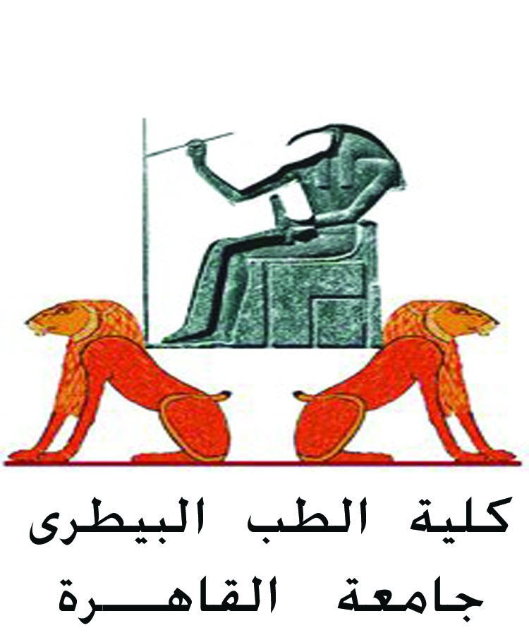 |  | 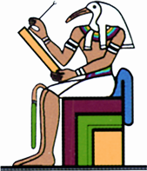  جامعة القاهرة

personal Information
Name | Aya Magdy Abdel Aziz Mekkawy | optional photo
Title | Lecturer at Cytology & Histology department.
Date of birth | 6-4-1991
Place of birth | Cairo
Citizenship | Egypt
Contact Information
Home phone | 02-27420561
Mobile phone | 01095556052
E-mail (s) | ayamagdy688@gmail.com
Current Address | 125 El-Fostat city, Cairo, Egypt
Educational Qualifications
- Master of Veterinary Science at Cytology and Histology department, Cairo University (2016).
- BSc. of Veterinary Medicine, Cairo University. With “very good” degree. (2013).
Academic Positions
- Assistant lecturer at faculty of veterinary medicine, Cairo University (jan-2017: now).
- Demonstrator faculty of veterinary medicine, Cairo University (Jan 2014: Dec 2016).
Thesis Title
- Some histological studies on the exocrine pancreas of buffalo (Bubalus bubalis).
Training courses
- (7) FLDC training courses (2014-2015).
- ICDL course at Cairo University (2015).
- TOEFL certificate at Language and Translation Center, Faculty of Arts, Cairo University (2015).
- Statistics certificate at Cairo University (2015).
  - Human resources and soft skills courses at Faculty of Veterinary Medicine, Cairo University.
- Creative Thinking workshop (2012).
- Microbiology Course at the Faculty of Veterinary Medicine (2011).
- First aid for emergency at the International Cultural Center (2010).
Computer Skills
- ICDL (Windows XP, Windows 7, Word, excel, access, Power point, IT).
- Excellent in using the Internet.
Language Skills
English (Toefl): Excellent (Spoken & Written).

